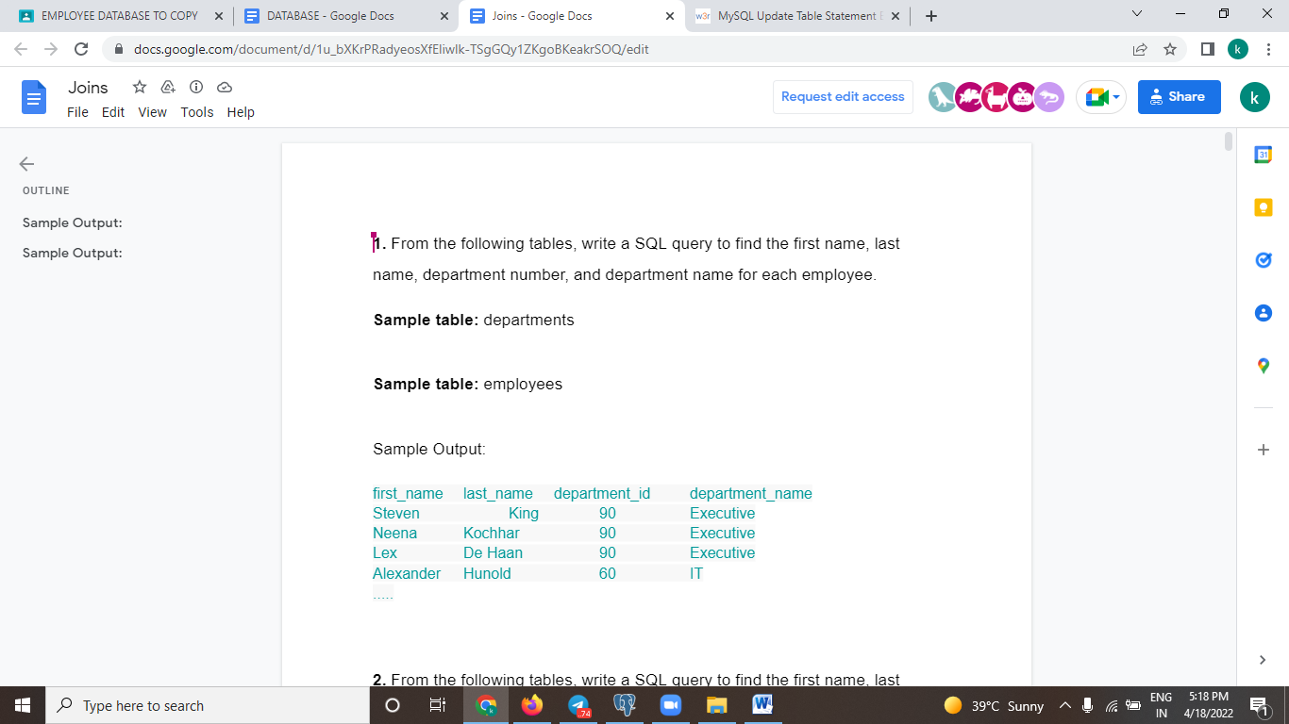

Answer:

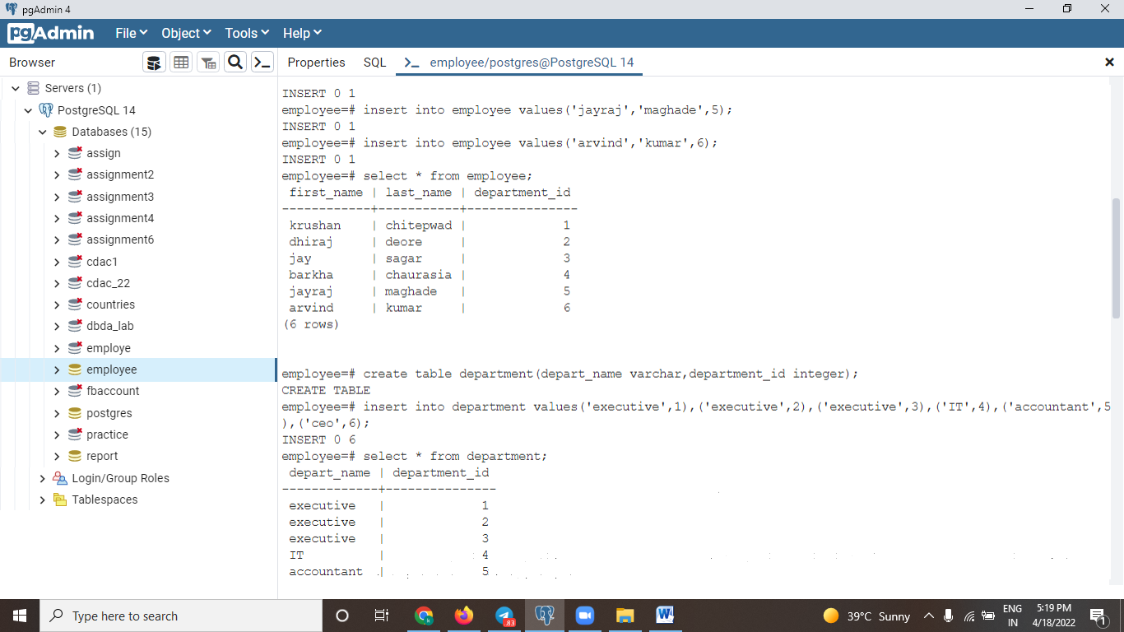

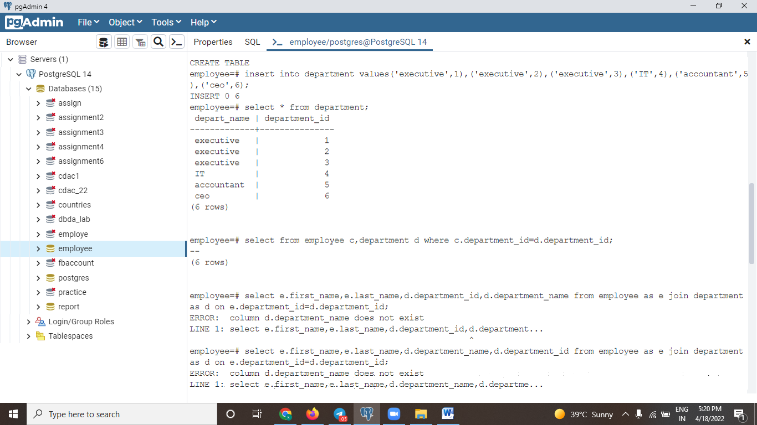

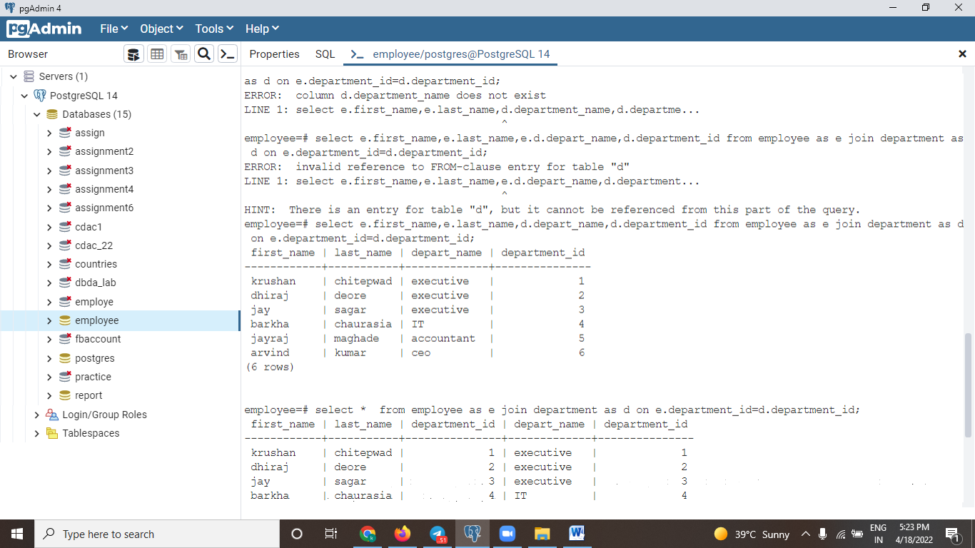

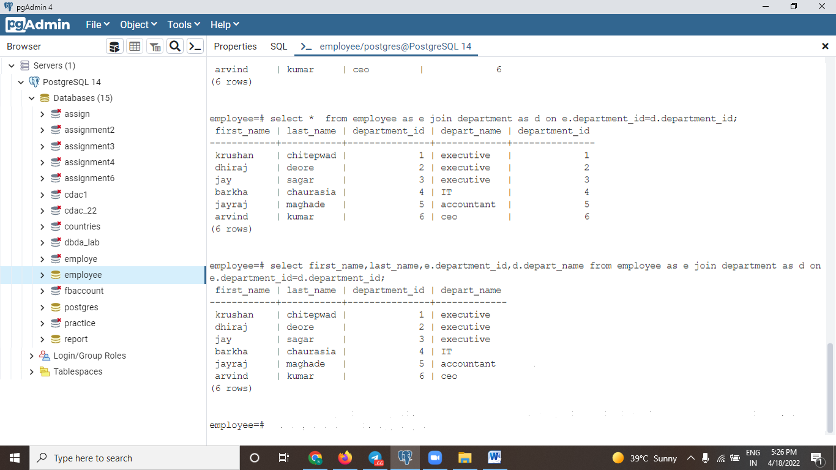

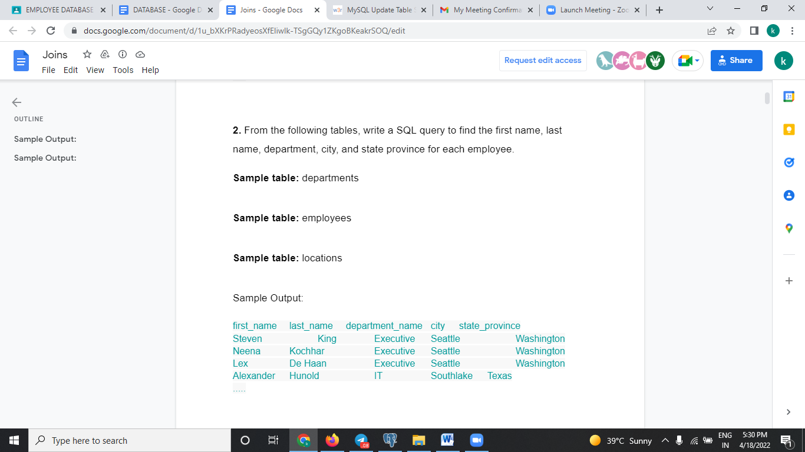

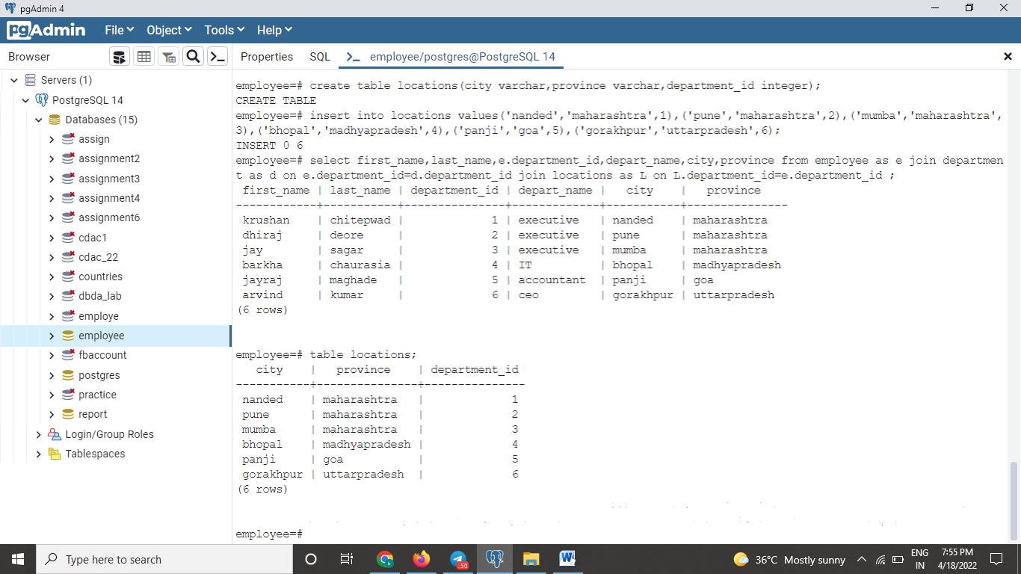

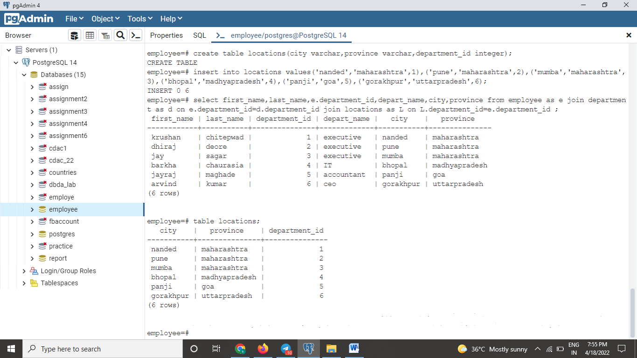

OR

SELECT E.first_name,E.last_name, D.department_name, L.city, L.state_province FROM employees E JOIN departments D ON E.department_id = D.department_id JOIN locations L ON D.location_id = L.location_id;

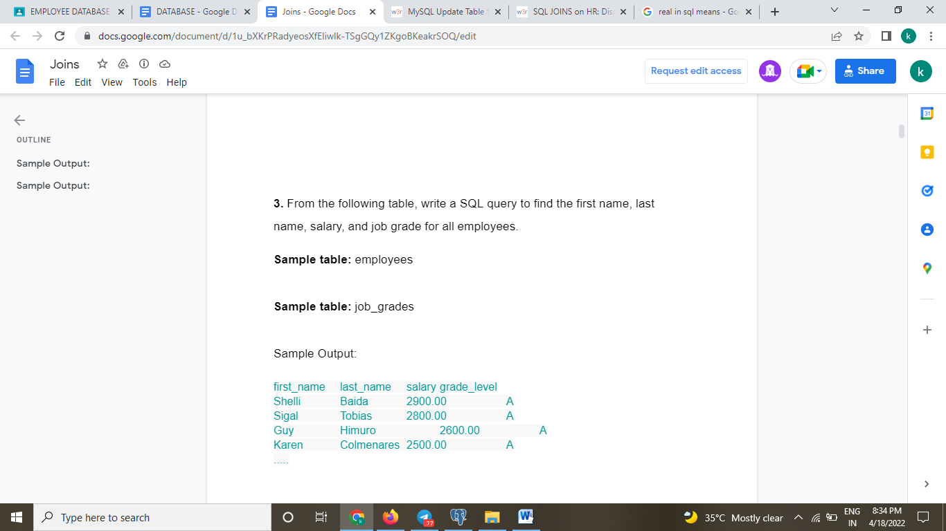

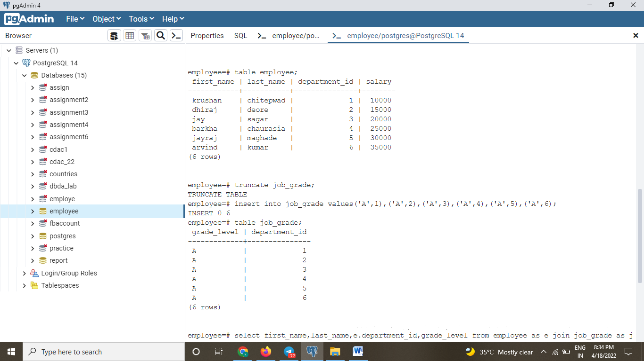

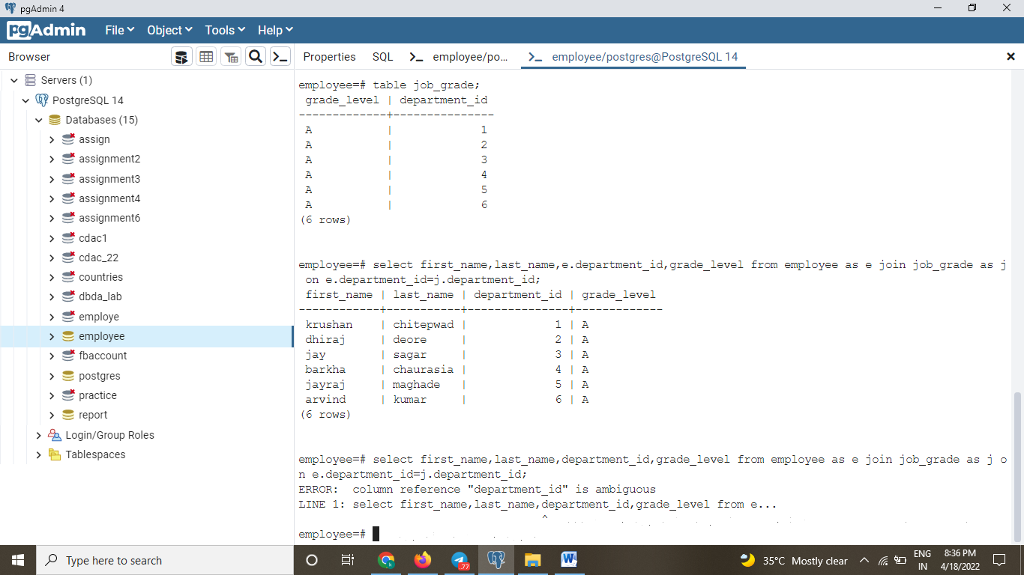

When you not mentioned alias .columnname error will come because one colums same in other tables also.

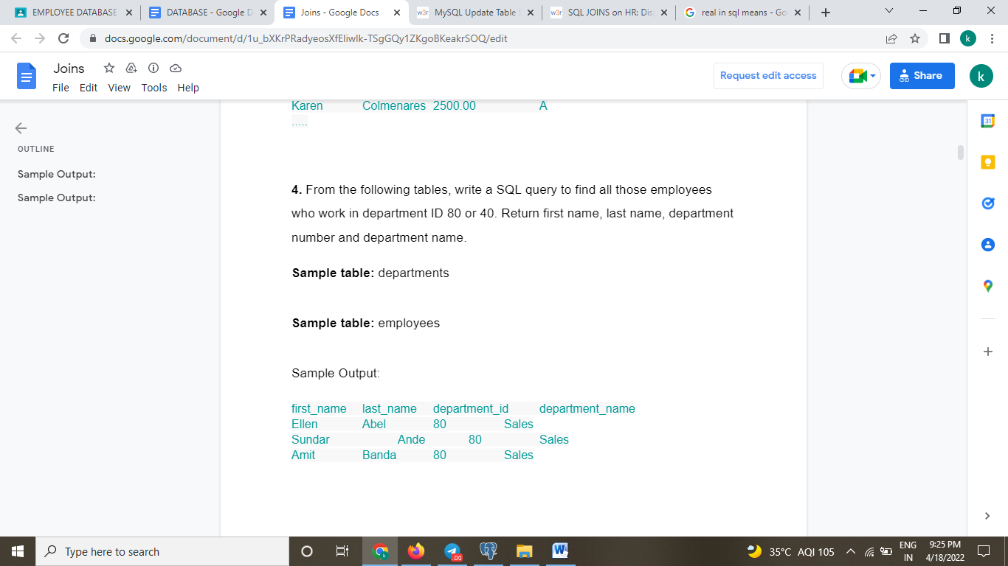

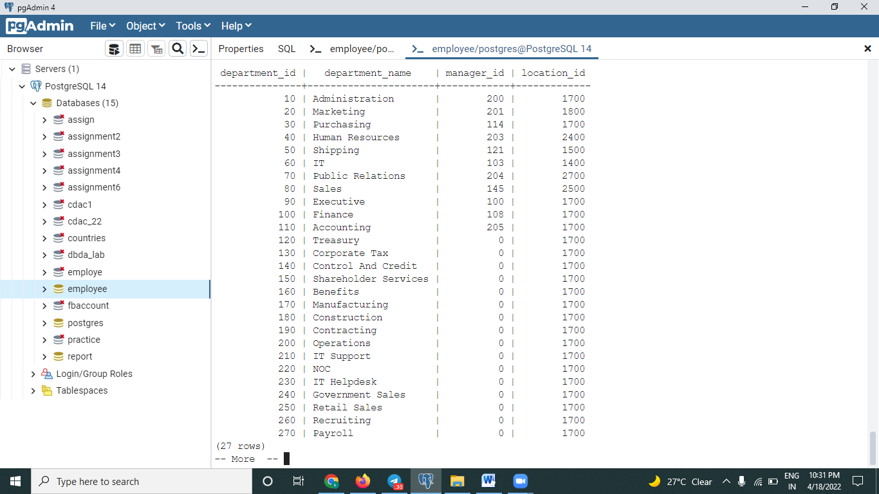

**6.** From the following table, write a SQL query to find all departments including those without any employee. Return first name, last name, department ID, department name.

**Sample table:** departments

**Sample table:** employees

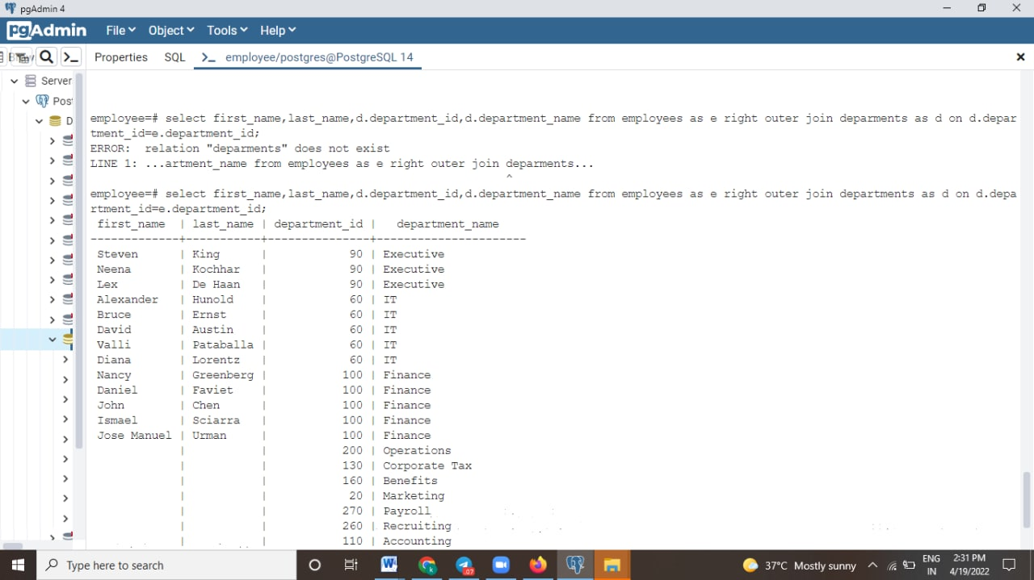

**7.** From the following table, write a SQL query to find those employees who earn less than the employee of ID 182. Return first name, last name and salary.

**Sample table:** employees

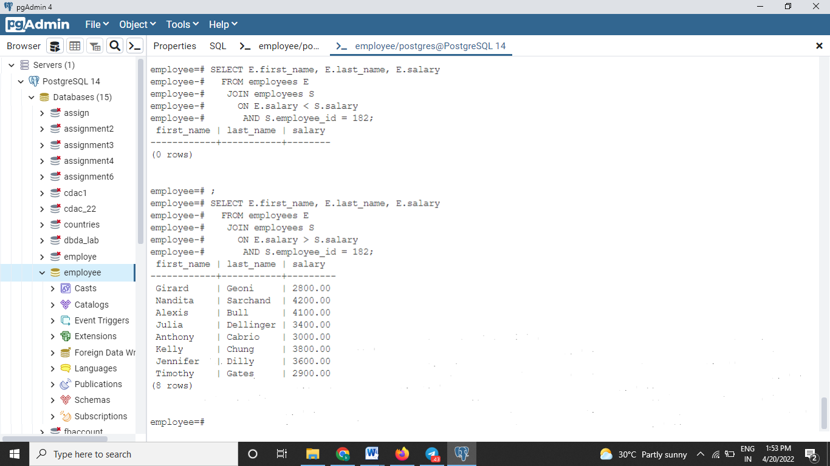

**8.** From the following table, write a SQL query to find the employees and their managers. Return the first name of the employee and manager.

**Sample table:** employees

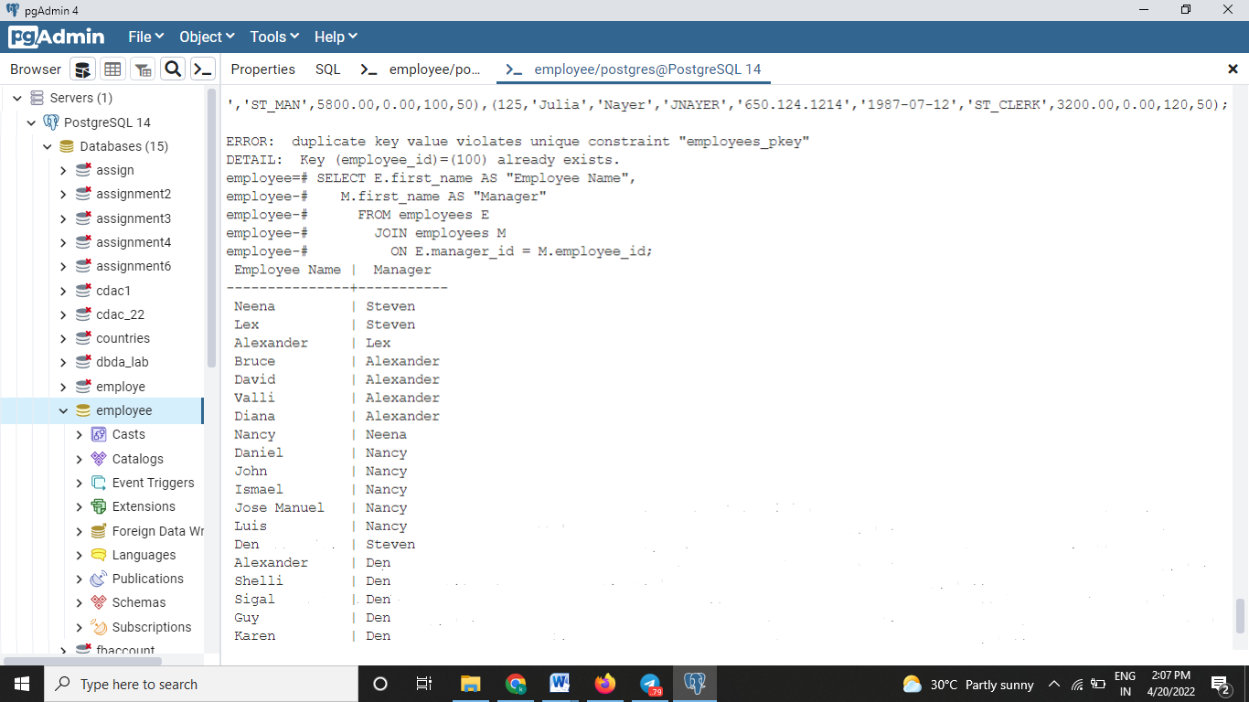

**9.** From the following tables, write a SQL query to display the department name, city, and state province for each department.

**Sample table:** departments

**Sample table:** locations

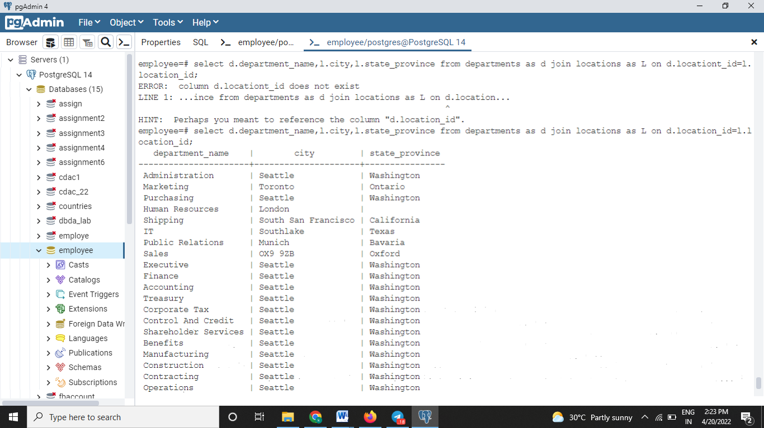

**10.** From the following tables, write a SQL query to find those employees who have or not any department. Return first name, last name, department ID, department name.

**Sample table:** departments

**Sample table:** employees

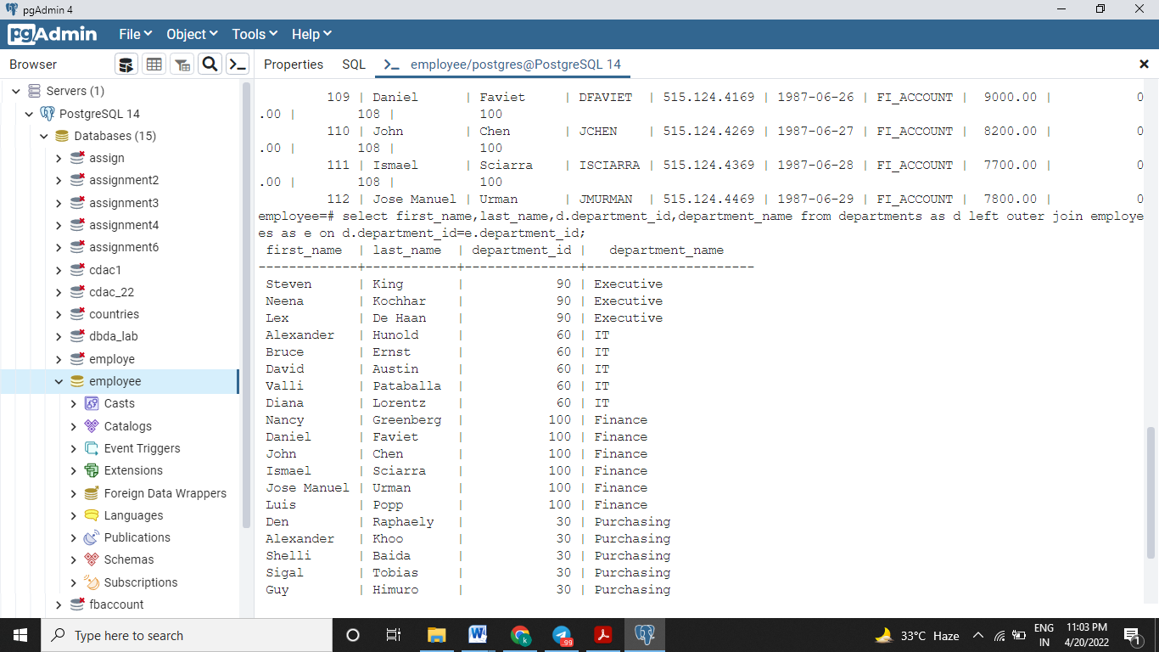

**11.** From the following table, write a SQL query to find the employees and their managers. These managers do not work under any manager. Return the first name of the employee and manager.

**Sample table:** employees

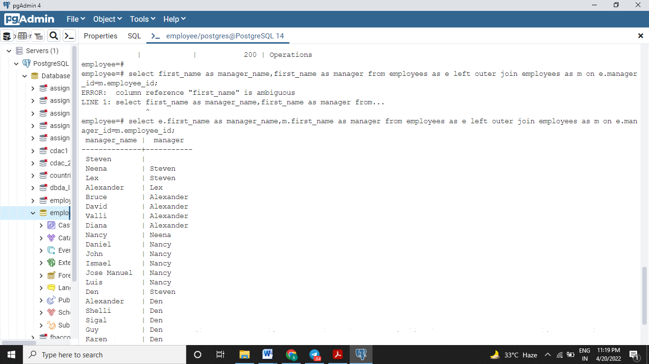

**12.** From the following tables, write a SQL query to find those employees who work in a department where the employee of last name 'Taylor' works. Return first name, last name and department ID.

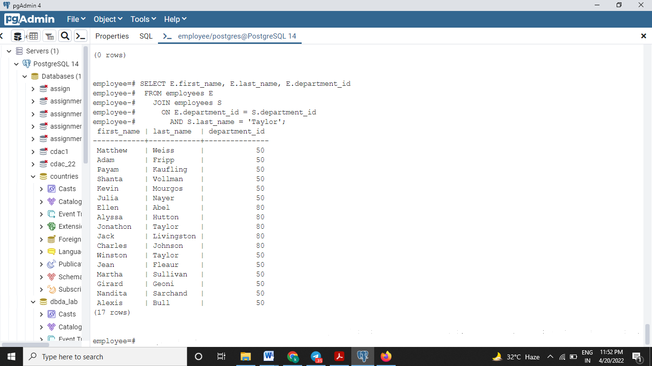

**13.** From the following tables, write a SQL query to find those employees who joined between 1st January 1993 and 31 August 1997. Return job title, department name, employee name, and joining date of the job.

Sample table: job_history

Sample table: employees

Sample table: jobs

Sample table: departments

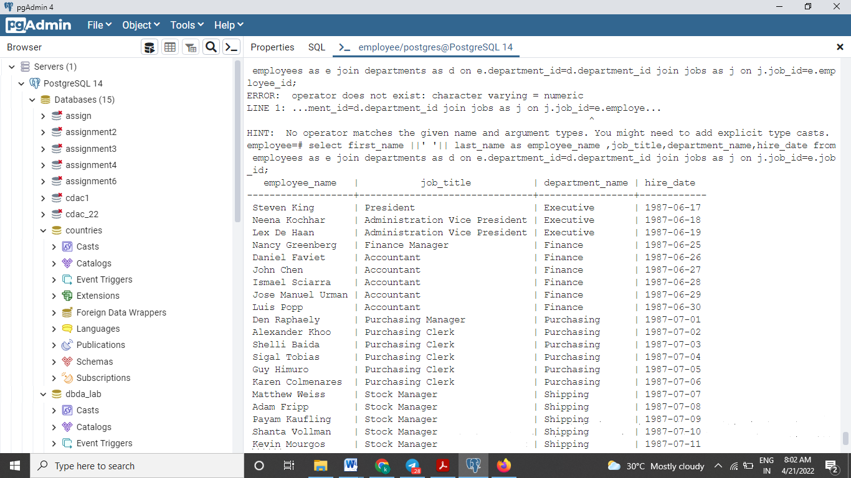

**14.** From the following tables, write a SQL query to find the difference between maximum salary of the job and salary of the employees. Return job title, employee name, and salary difference.

Sample table: employees

Sample table: jobs

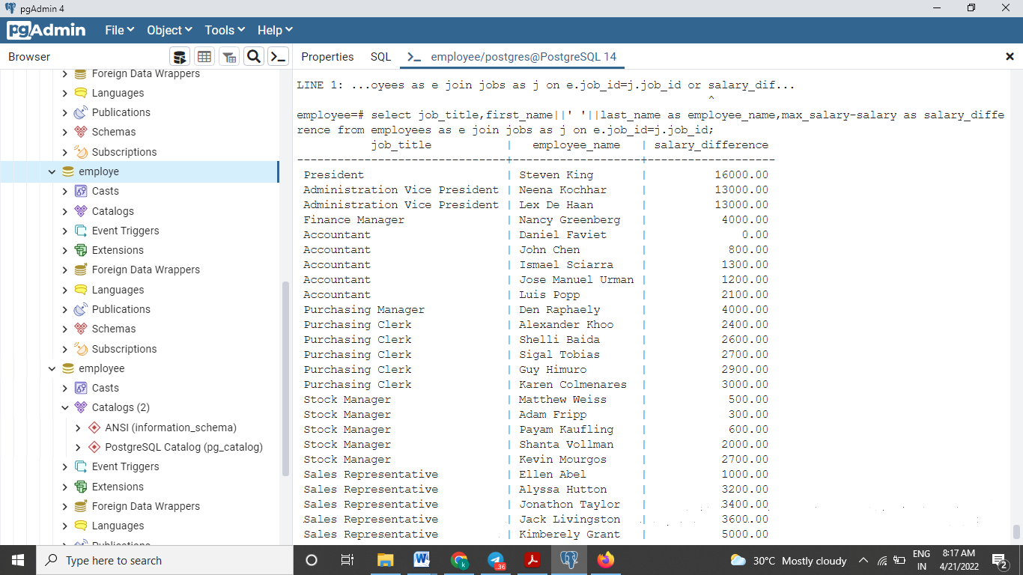

**15.** From the following table, write a SQL query to compute the average salary, number of employees received commission in that department. Return department name, average salary and number of employees.

Sample table: employees

Sample table : departments

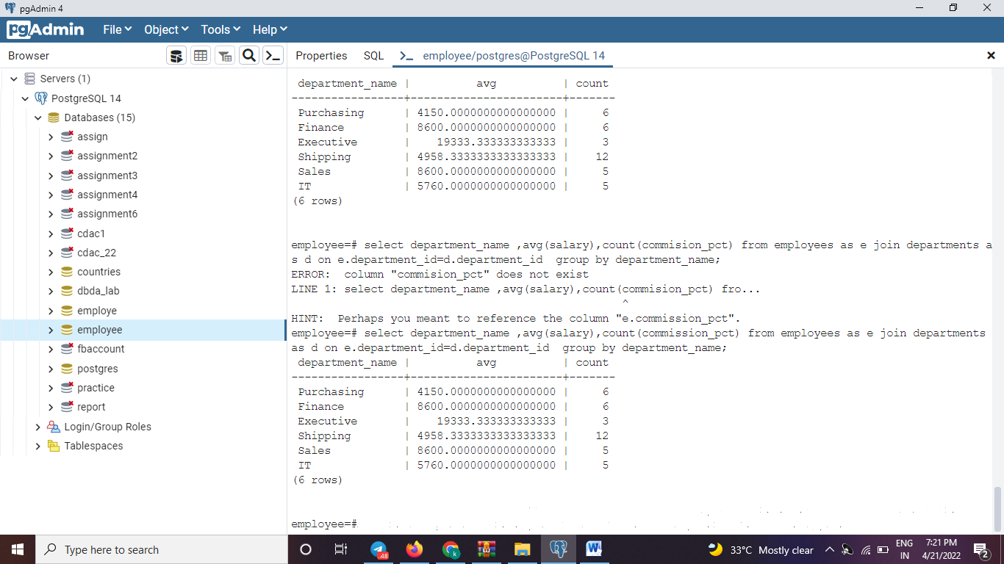

**16.** From the following tables, write a SQL query to compute the difference between maximum salary and salary of all the employees who works the department of ID 80. Return job title, employee name and salary difference.

Sample table: employees

Sample table: jobs

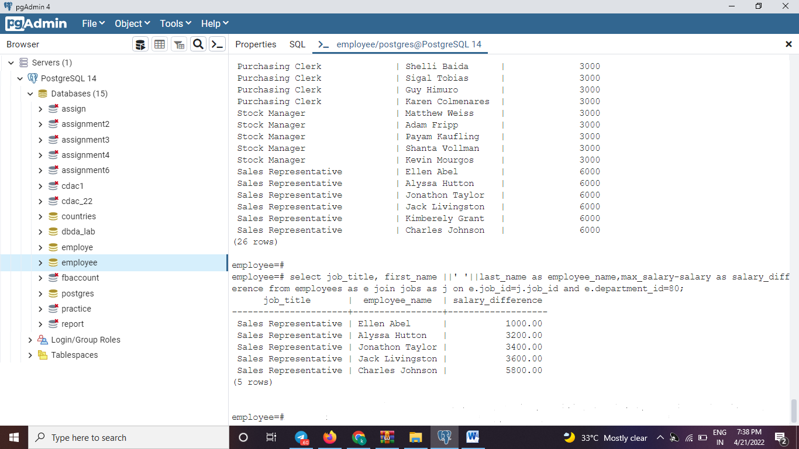

**17.** From the following table, write a SQL query to find the name of the country, city, and departments, which are running there.

Sample table: countries

Sample table: locations

Sample table: departments

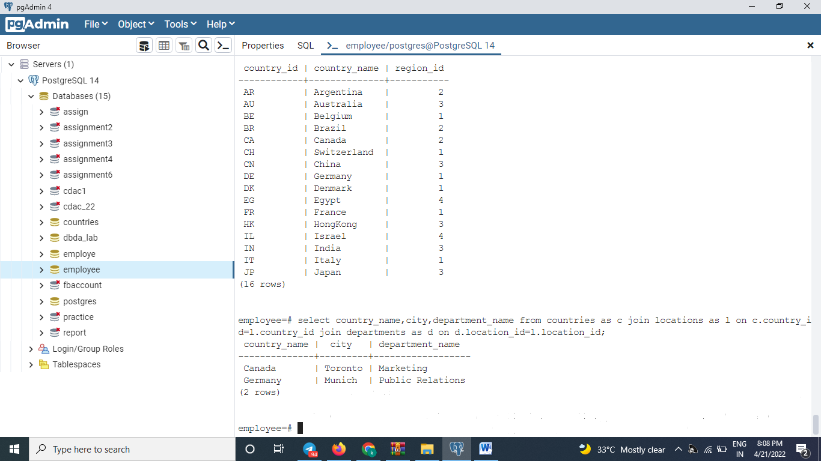

**18.** From the following tables, write a SQL query to find the department name and the full name (first and last name) of the manager.

**Sample table:** departments

Sample table: employees

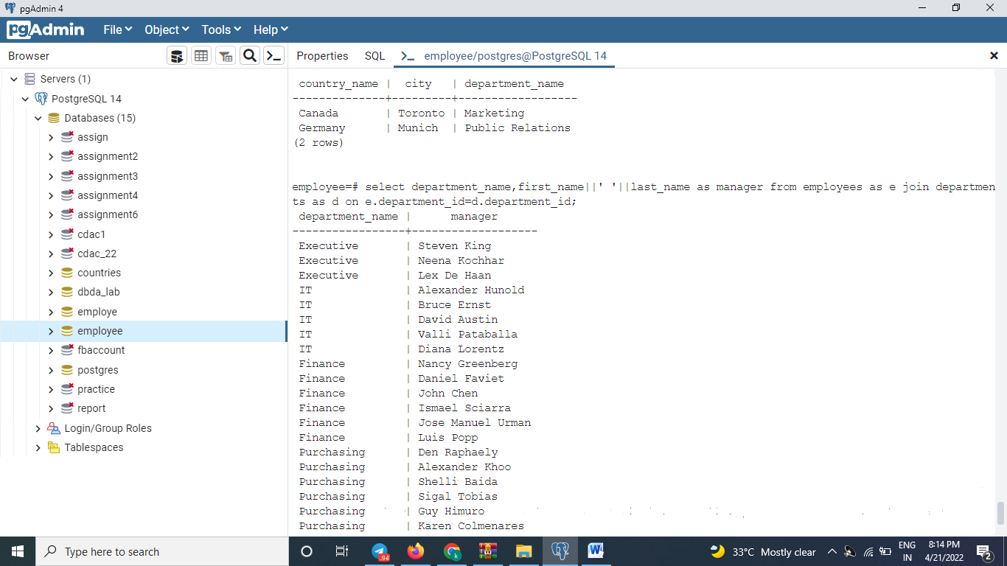

**19.** From the following table, write a SQL query to compute the average salary of employees for each job title.

**Sample table:** employees

Sample table: jobs

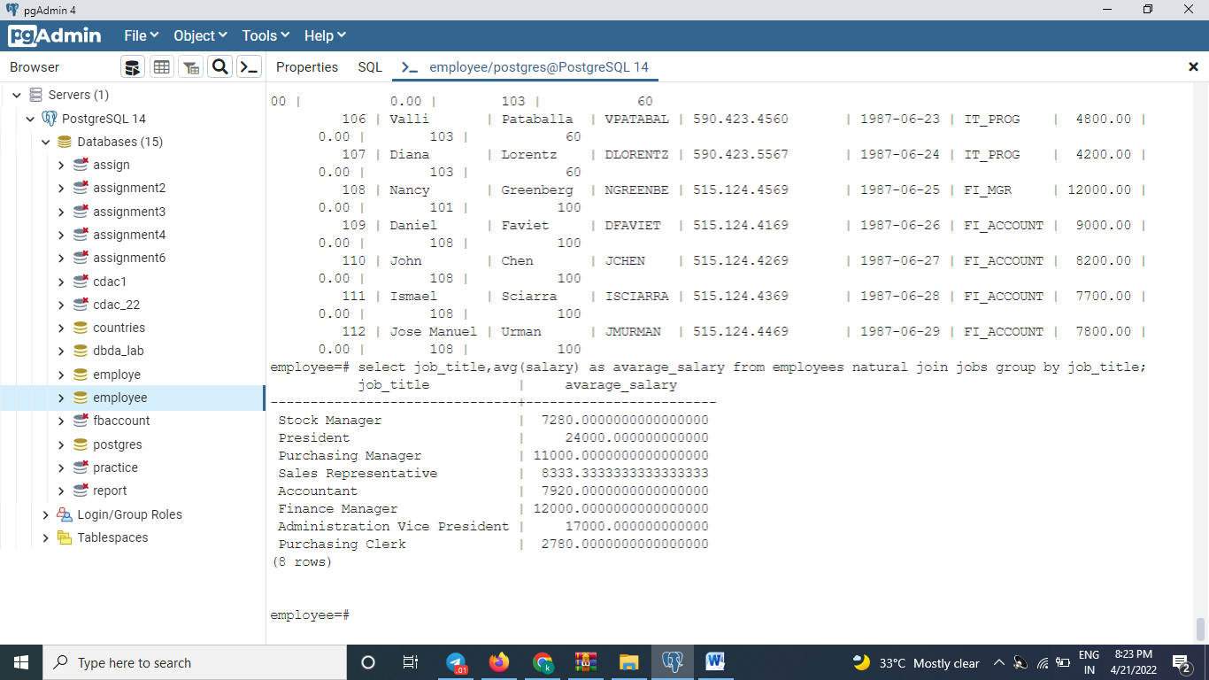

**20.** From the following table, write a SQL query to find those employees who earn $12000 and above. Return employee ID, starting date, end date, job ID and department ID.

Sample table: employees

Sample table: job_history

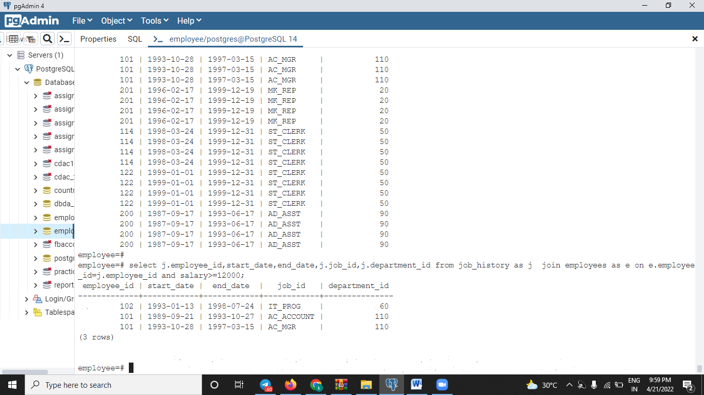

**21.** From the following tables, write a SQL query to find those departments where at least 2 employees work. Group the result set on country name and city. Return country name, city, and number of departments.

Sample table: countries

Sample table: locations

Sample table: employees

Sample table: departments

SELECT country_name,city, COUNT(department_id)

FROM countries

JOIN locations USING (country_id)

JOIN departments USING (location_id)

WHERE department_id IN

(SELECT department_id

FROM employees

GROUP BY department_id

HAVING COUNT(department_id)>=2)

GROUP BY country_name,city;

**22.** From the following tables, write a SQL query to find the department name, full name (first and last name) of the manager and their city.

Sample table: employees

Sample table: departments

Sample table: locations

**23.** From the following tables, write a SQL query to compute the number of days worked by employees in a department of ID 80. Return employee ID, job title, number of days worked.

Sample table: jobs

Sample table: job_history

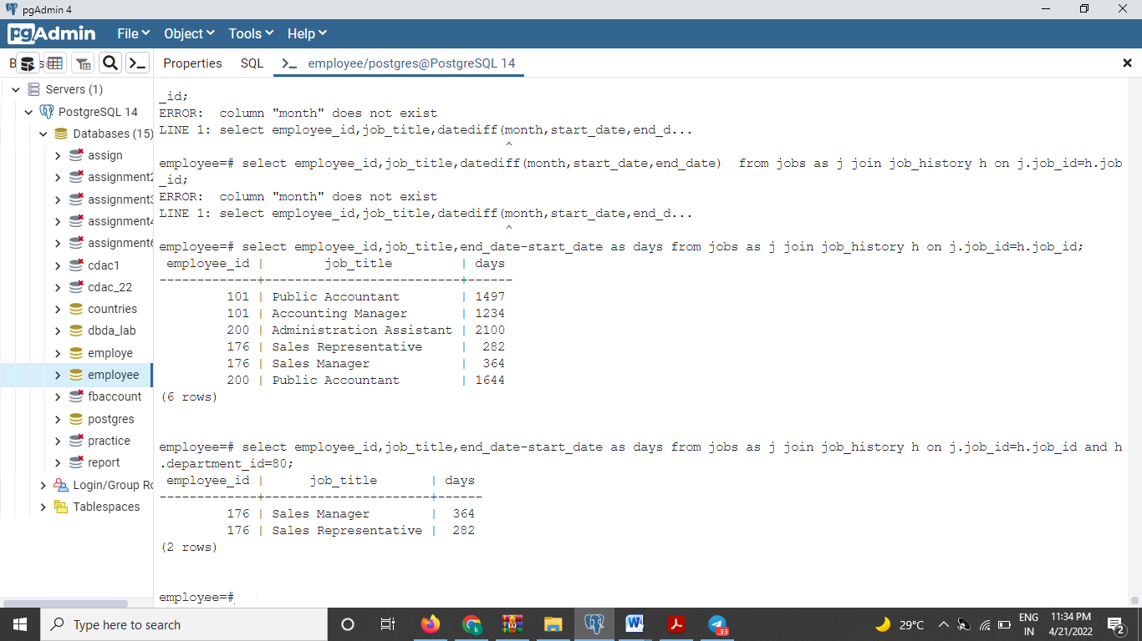

**24.** From the following tables, write a SQL query to find full name (first and last name), and salary of those employees who work in any department located in 'London' city.